**Short instructions:**

The top of the femur is always round and it sits inside a concentric ring. Make sure you highlight the round femur head, and not the bone it sits in.

**Examples:**

**Good**

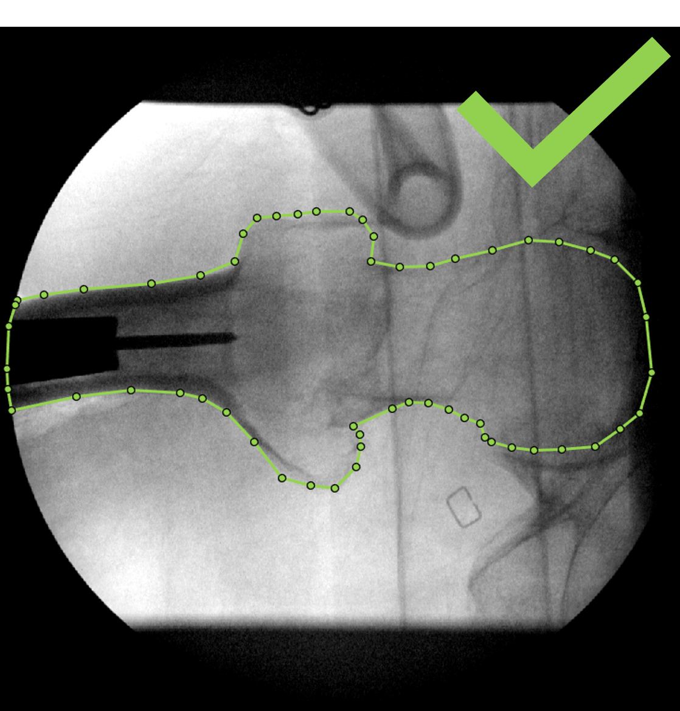

**Bad**

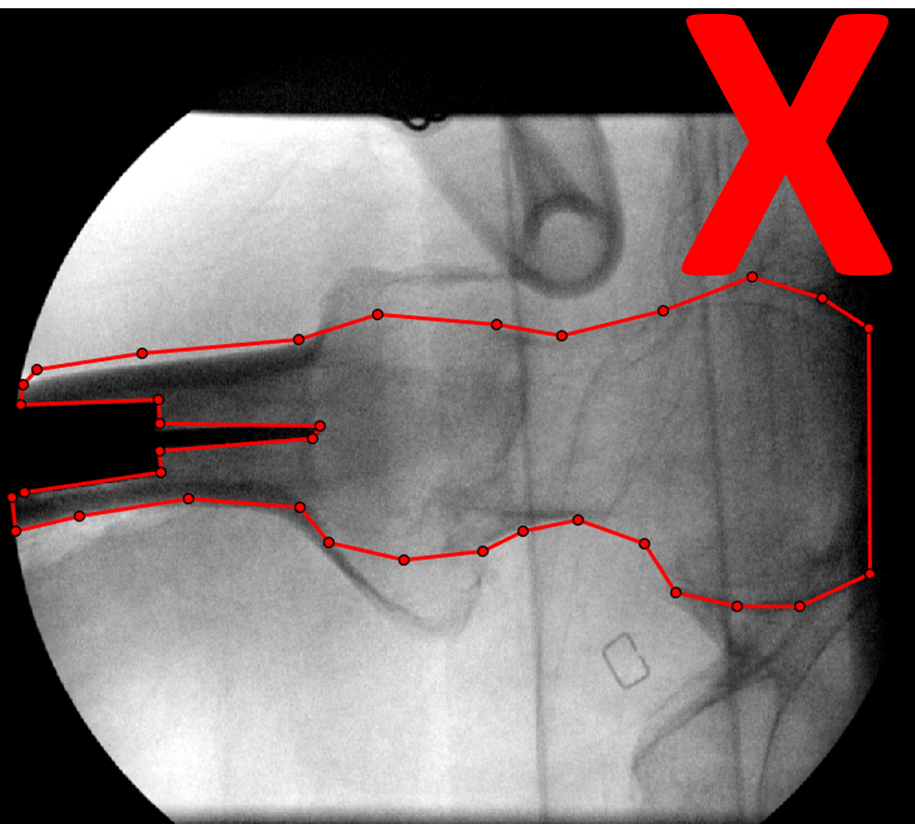

**Good**

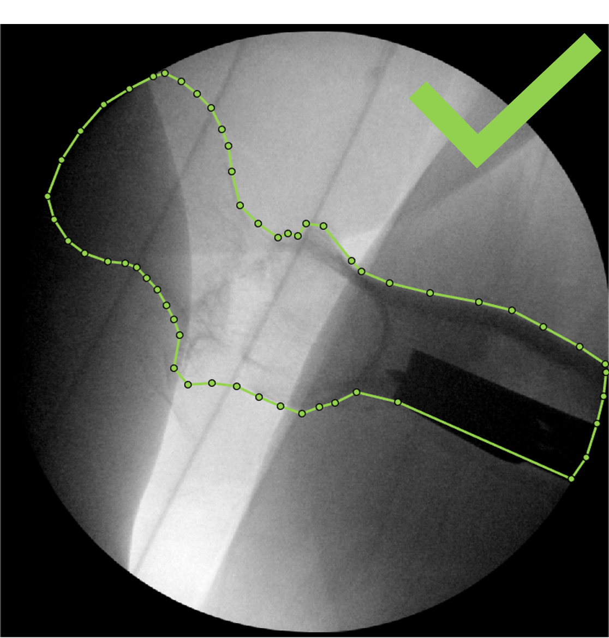 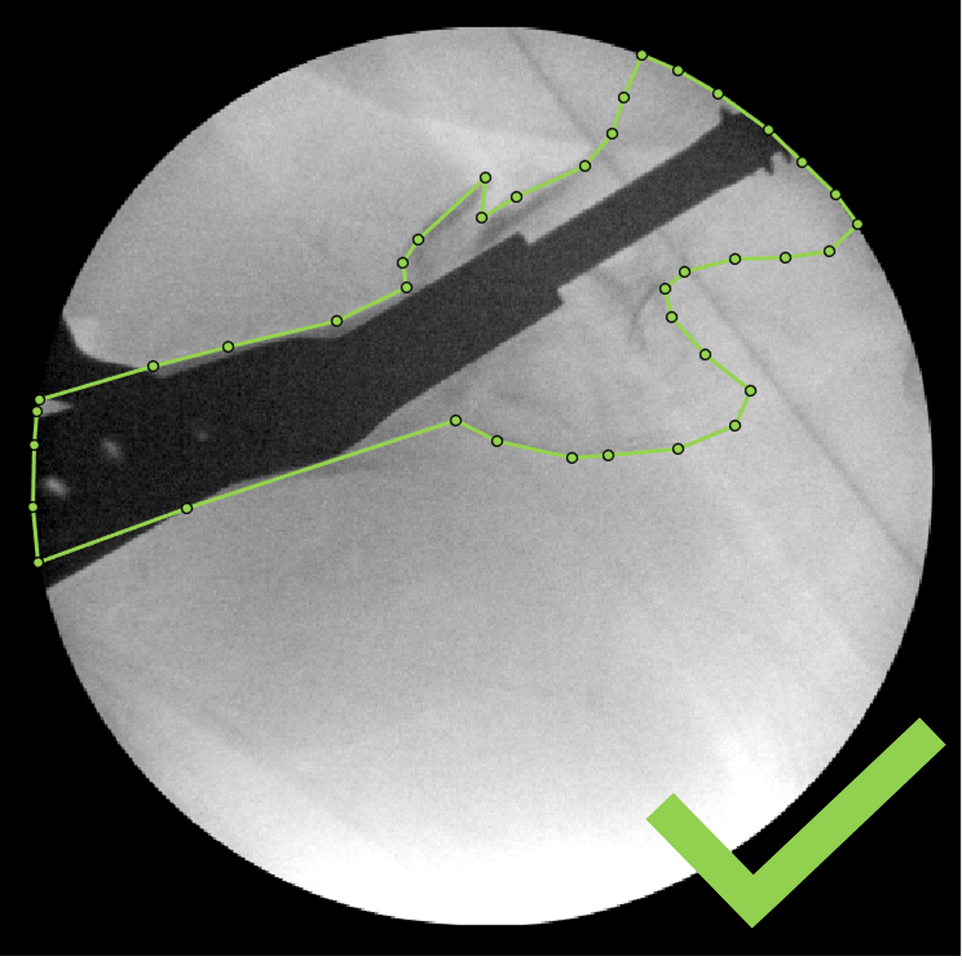

**Bad**

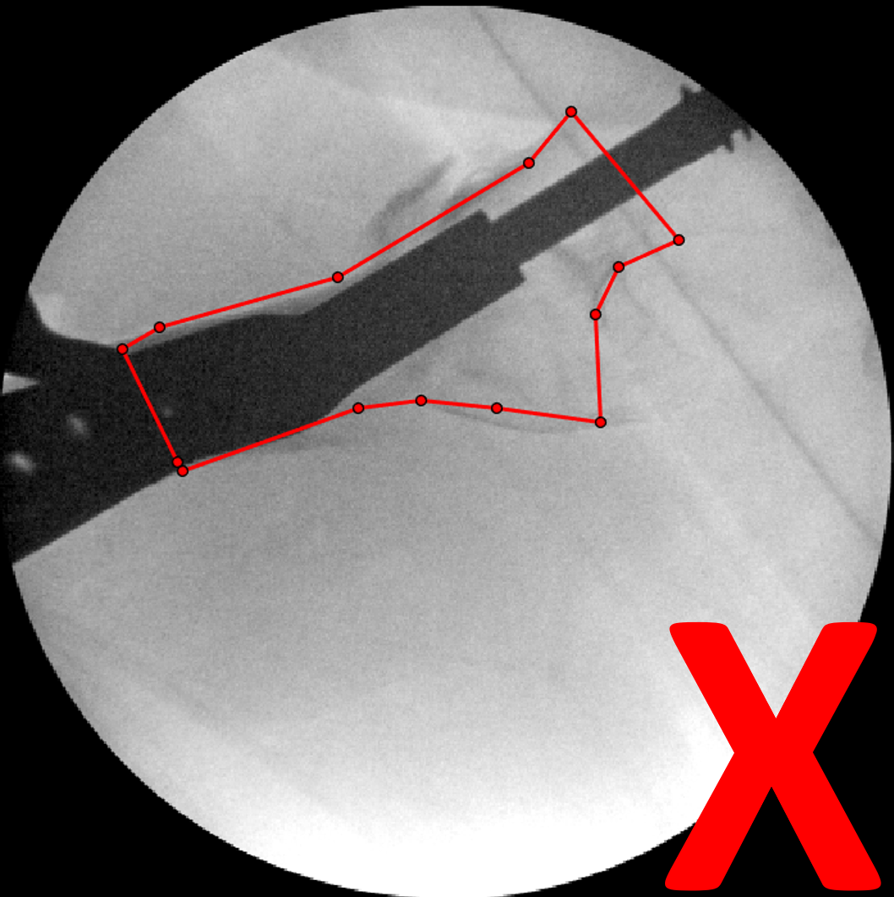

**More Instructions:**

This is a semantic segmentation task for medical analysis. Please outline the femur bone carefully, paying extra attention to the femur head.

Please draw over (ignore) any surgical hardware covering the femur (the solid black foreign objects), estimating the femur's outline if you need to.

These images were taken during surgery. They may have low contrast in certain cases and the femur may be fractured.

Please study the anatomy of the femur (below) if you are ever uncertain about the segmentation:

